Mathis Magnier

Aymane Benafquir

**SAE 2.04 - English**

A bar graph to show the evolution in the numbers of all applicants between 2006 and 2023

1a) :

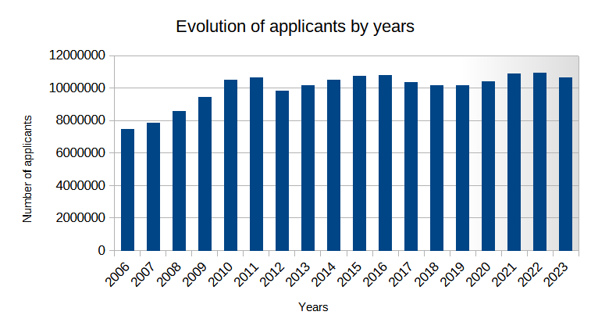

1b) :

A bar graph to show the evolution in the numbers of international applicants from the EU (excluding UK) between 2006 and 2023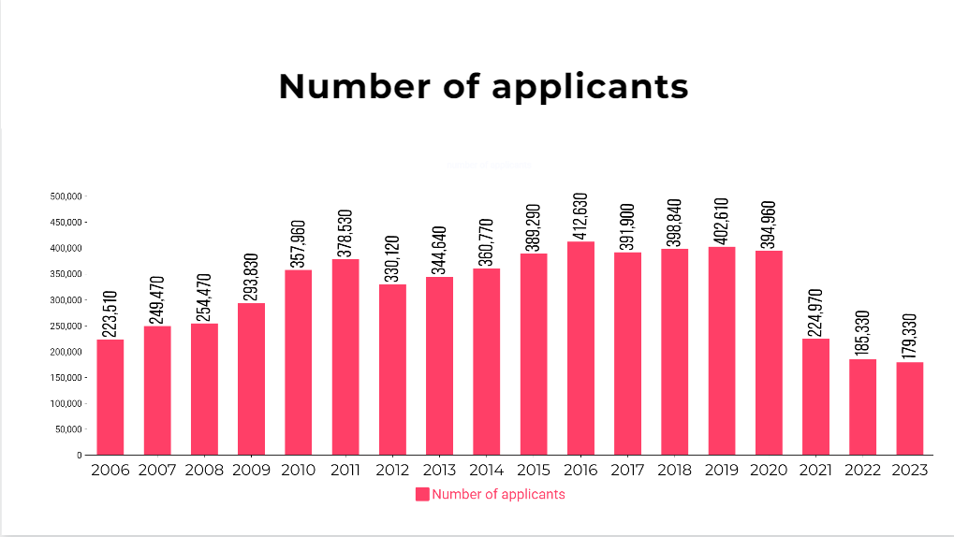

1c) :

A bar graph to show the evolution in the numbers of international non-EU applicants between 2006 and 2023 : 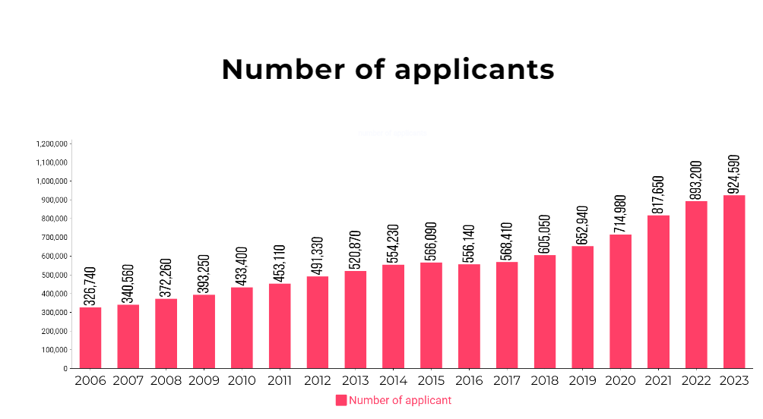

2)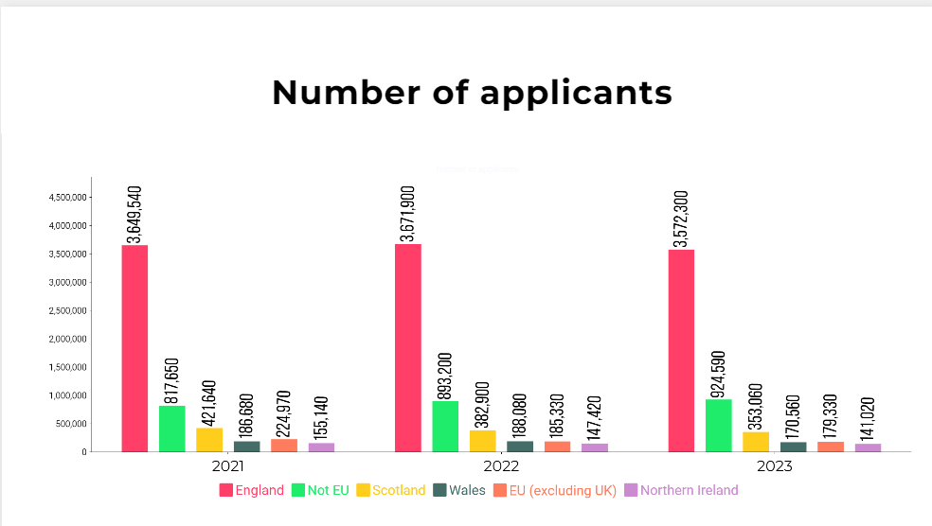

As we can see on the bar graph just before, England has the most applicants over the 3 years, which is understandable since these are applicants from English universities. Over these 3 years, the data remains very stable and changes little

3)

To see if Brexit had an effect on the number of French applicants to UK universities we created a bar graph of the French applicants group by years.And as we can see, the Brexit really had an effect on the number of French applicants to UK universities because one year before Brexit there were 21,350 candidates while in 2021 (one year later) there were 14,420 candidates and this number was decreasing from year to year.

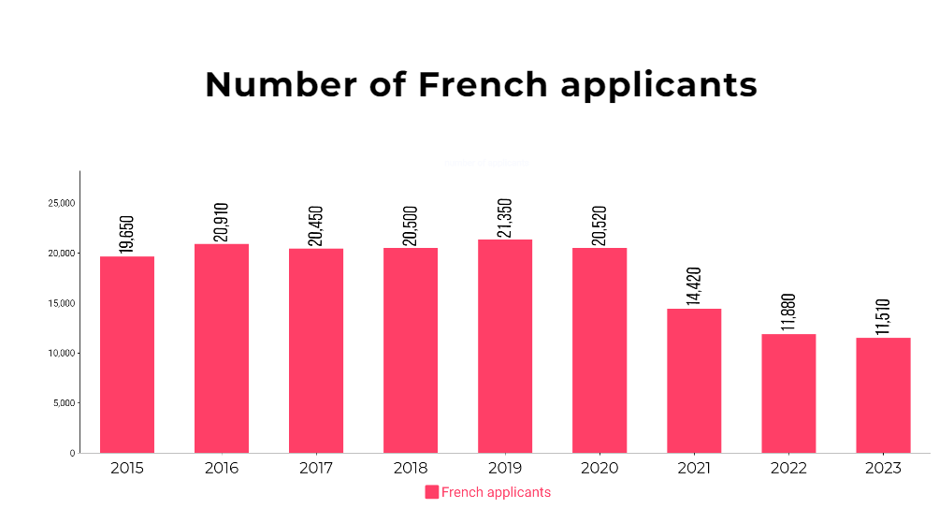

4)

The country (excluding the UK) who had the highest number of applicants in June 2023 is China with 122820 applicants.

5)

The country (excluding the UK) who had the highest number of female applicants in June 2023 is China again with 31790 applicants.

6) The bar graph just below shows the change in Australian female applicants year by year. And as we can see, the number of 18 year old applicants is the highest every year. 19 year old applicants are right behind almost every year. Applications for 18 year olds increased between 2006 and 2014 then decreased until 2017 then increased the next 2 years, decreased again from 2020 to 2021 and exploded until reaching a peak in 2023.

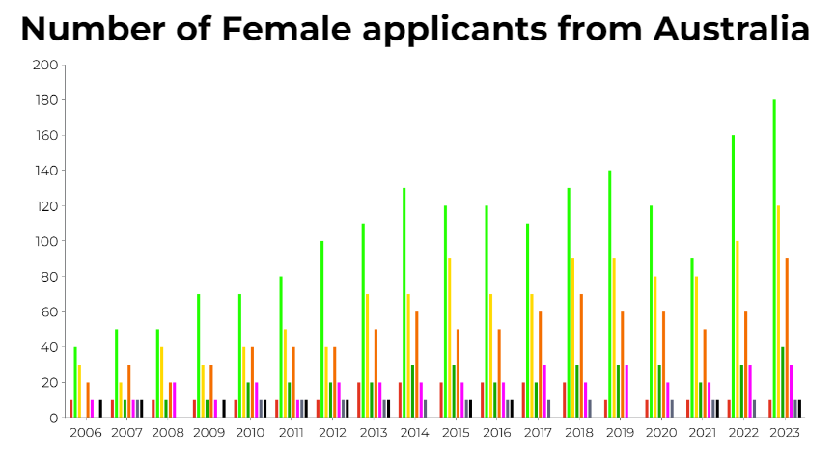



The bar graph just below shows the change in Australian male applicants year by year. And as we can see, the number of 18 year old applicants is the highest practically every year (not in 2008, it was 19 years old applicants.).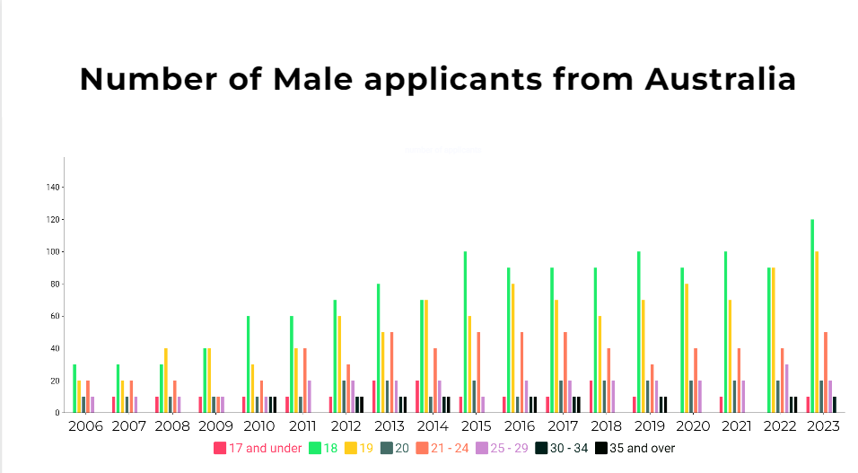

The number of 18 year old male applicants from Australia is lower than the number of 18 year old female applicants.

7) The bar graph just below shows the change in Chinese female applicants year by year. And as we can see, the number of 19 year old applicants is the highest every year between 2006 and 2015, then 18 year old applicants pass them until June 2023. The number of Chinese females increased steadily between 2006 and 2023.

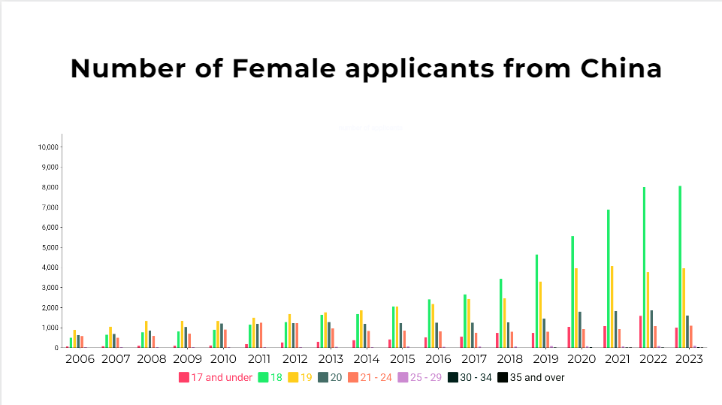

The bar graph just below shows the change in Chinese male applicants year by year. And as we can see, the number of applicants stayed around 1000 by ages between 2006 and 2015. Then it exponentially especially increased 18 year old applicants.

the number of 18 year old male applicants from China is practically the same than the number of 18 year old female applicants.

